Website Report

Name: Aaron Mc Kenna Lappin

Student Number: S00233610

Date: 10/4/2023

**Proposed Page Web Site Topic**

I created a fake website for a doorbell that flashes instead of making noise for deaf people

**Proposed design**

The website will have a gradient background that is pink and green.

**Rough proposed sketch of website home page.**

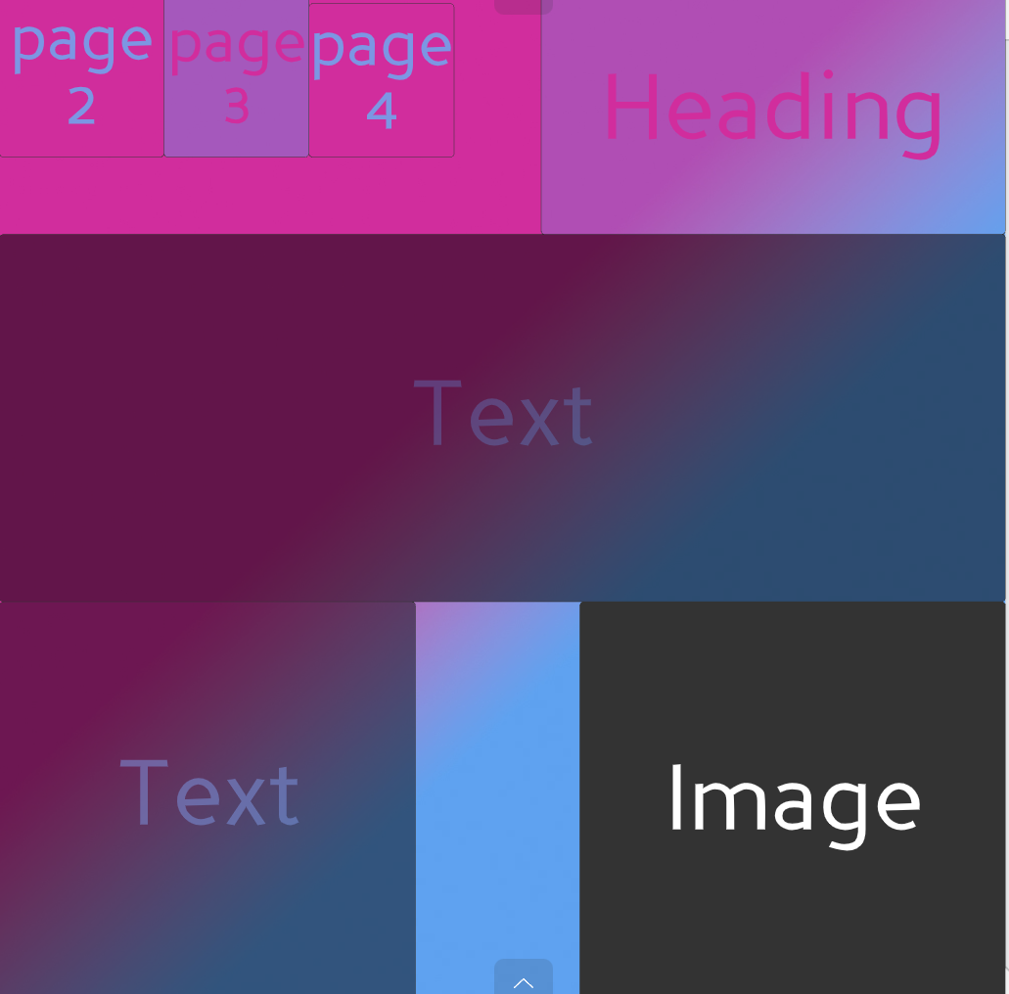

The colours got changed from the original design instead of blue it got changed to green.

**Github url**

**Features Checklist**

